**YARN**

**Student Name: Student Id:**

**Date:**

Please use the screenshots ONLY as a reference. The written instructions have to be followed AS written.

PLEASE MAKE SURE YOU SUBMIT ALL THE SCREENSHOTS WITH TIMESTAMPS AT THE BOTTOM RIGHT (WINDOWS USERS) OR THE TOP RIGHT (MAC OSX USERS) OR ELSE YOU WILL AUTOMATICALLY QUALIFY FOR A DISCOUNT.

# Objective:

YARN is a Hadoop processing layer that contains a Resource Manager (RM) and job scheduler. YARN allows multiple processing engines to run on a single Hadoop Cluster. The objective of this exercise is to help the students understand how Yet Another Resource Negotiator (YARN) distributes tasks in a job over a cluster, and how to monitor an application and view its log files. We will be running a spark job on the files in the KB directory that we imported into HDFS in exercise 1.

**NOTE:**

* **Code to be executed is highlighted in Green**
* **The explanation for all the code is provided below the code**
* **There are subtle differences in HDFS commands and common Linux commands, if you are running into an error, or not seeing what you expect double check the commands**
* **Some commands contain a (\) at the end of the first line, this signifies that the command is not complete. You may enter the code as it is shown on two lines or on one line without the “\”**
* **Maximize the terminal screen and increase the font to a visible size, otherwise points will be deducted**

Table of Contents

Objective: 1

Part-1: Introduction to YARN: 3

Part-2: Monitoring a Job in YARN and HUE: 7

Part-3: Finding Help: 12

Part-4: Checksum: 13

ADDITIONAL NOTES: 15

Part-1: Introduction to YARN: This section is to help the student navigate through the YARN UI and HUE job browser.

Step-1: Start the Cloudera VM and start the Firefox browser.

Q. Take a screenshot of the Firefox browser splash screen and paste it below.

Step-2: Click on the YARN Resource Manager tab in the bookmarks bar highlighted in the screenshot below.

Q. Take a screenshot of the YARN RM splash screen and paste it below.

Explanation: The fundamental idea of YARN is to split up resource management and job scheduling/monitoring in to separate domains. The cluster is currently at rest because there are no jobs running at the moment.

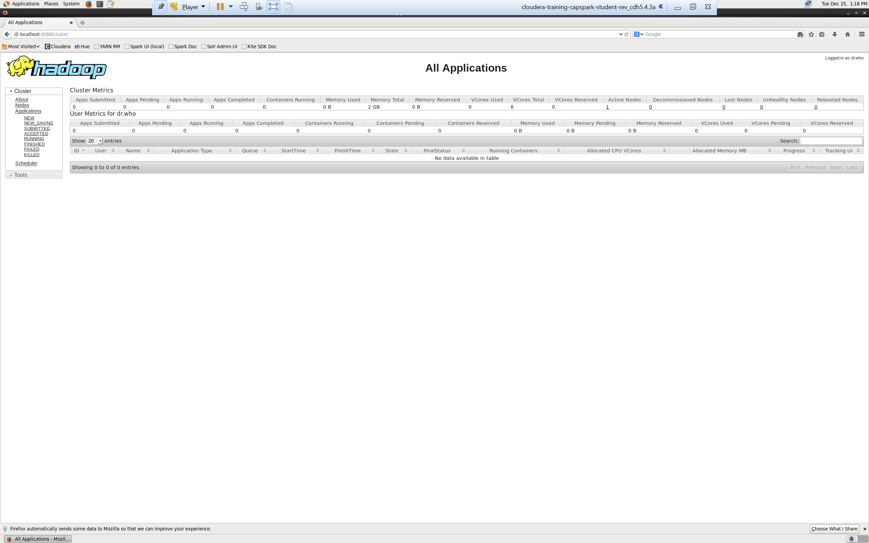Step-3: Look at the cluster metrics section shown in the screenshot below.

Explanation: The Yarn homepage shows general information about the cluster.

Q. Take a screenshot of the YARN UI highlighting the cluster metrics section. What kind of information is shown in the cluster metrics section?

Step-4: Click on the node link in the cluster menu section on the left side of the screen as shown in the screenshot below.

Q. Take a screenshot of the node screen. Highlight the information about the node at the bottom of the screen.

Explanation: The bottom section displays information about the worker nodes in the cluster. We only see a single node because we are using a pseudo-distributed cluster. In a production environment, you will have more than one node, and you should be able to see information about all your nodes in this screen. If you click on a specific node you will get more detailed information about that node.

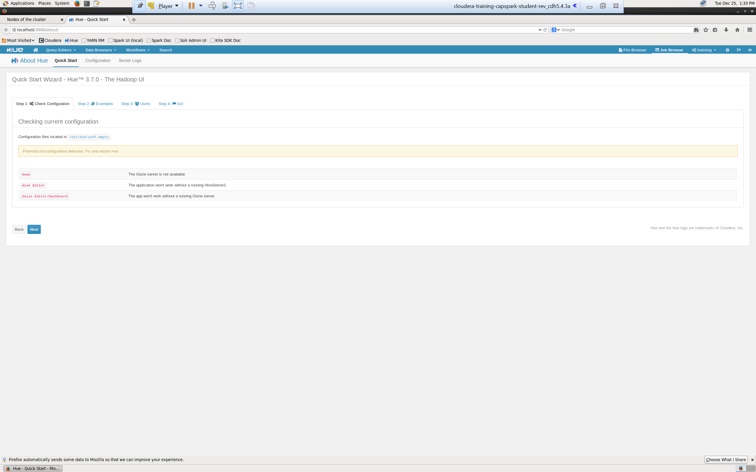Step-5: Open another tab in the Firefox browser, open HUE and select the Job Browser button as shown in the screenshot below.

Q. Take a screenshot of the HUE job browser splash screen and paste it below.

Explanation: The HUE job browser allows the user to monitor the status of a job, view the logs, and kill a job (terminate)

NOTE:

* If you do not see your application running, wait for a few second. It may take some time for the application to appear

Part-2: Monitoring a Job in YARN and HUE: In this section we will simulate a Spark application, and view cluster specific metrics and job specific metrics using the YARN UI and Job browser in HUE while the application is running.

Step-6: Open the terminal application on the Cloudera VM desktop.

Q. Take a screenshot of the terminal application and paste it below.

Step-7: Execute the following command at the shell prompt:





Q. Now type the command and execute. Take a screenshot of the shell output, highlight the wordcount.py file and paste it below.

Step-8: Execute the following command at the shell prompt:

Explanation: The above command is starting a spark application to count the number of words in the files located in the kb directory that we imported in to HDFS in exercise 1.

Q. Paste a screenshot of the shell output below.

NOTES:

1. This command starts the spark job, we will not pay much attention to the syntax of the spark job, that will come later on in the semester
2. Replace FirstName and LastName with your first name and last name, DO NOT copy as is

Step-9: Switch back to the HUE job browser and refresh the page.

Q. Take a screenshot of the Job Browser splash screen and highlight the job. Please type the ID and name underneath your screenshot.

Step-10: Now switch over the other tab in Firefox that is running the YARN Resource Manager UI.

Q. Take a screenshot of the YARN UI screen and paste it below.

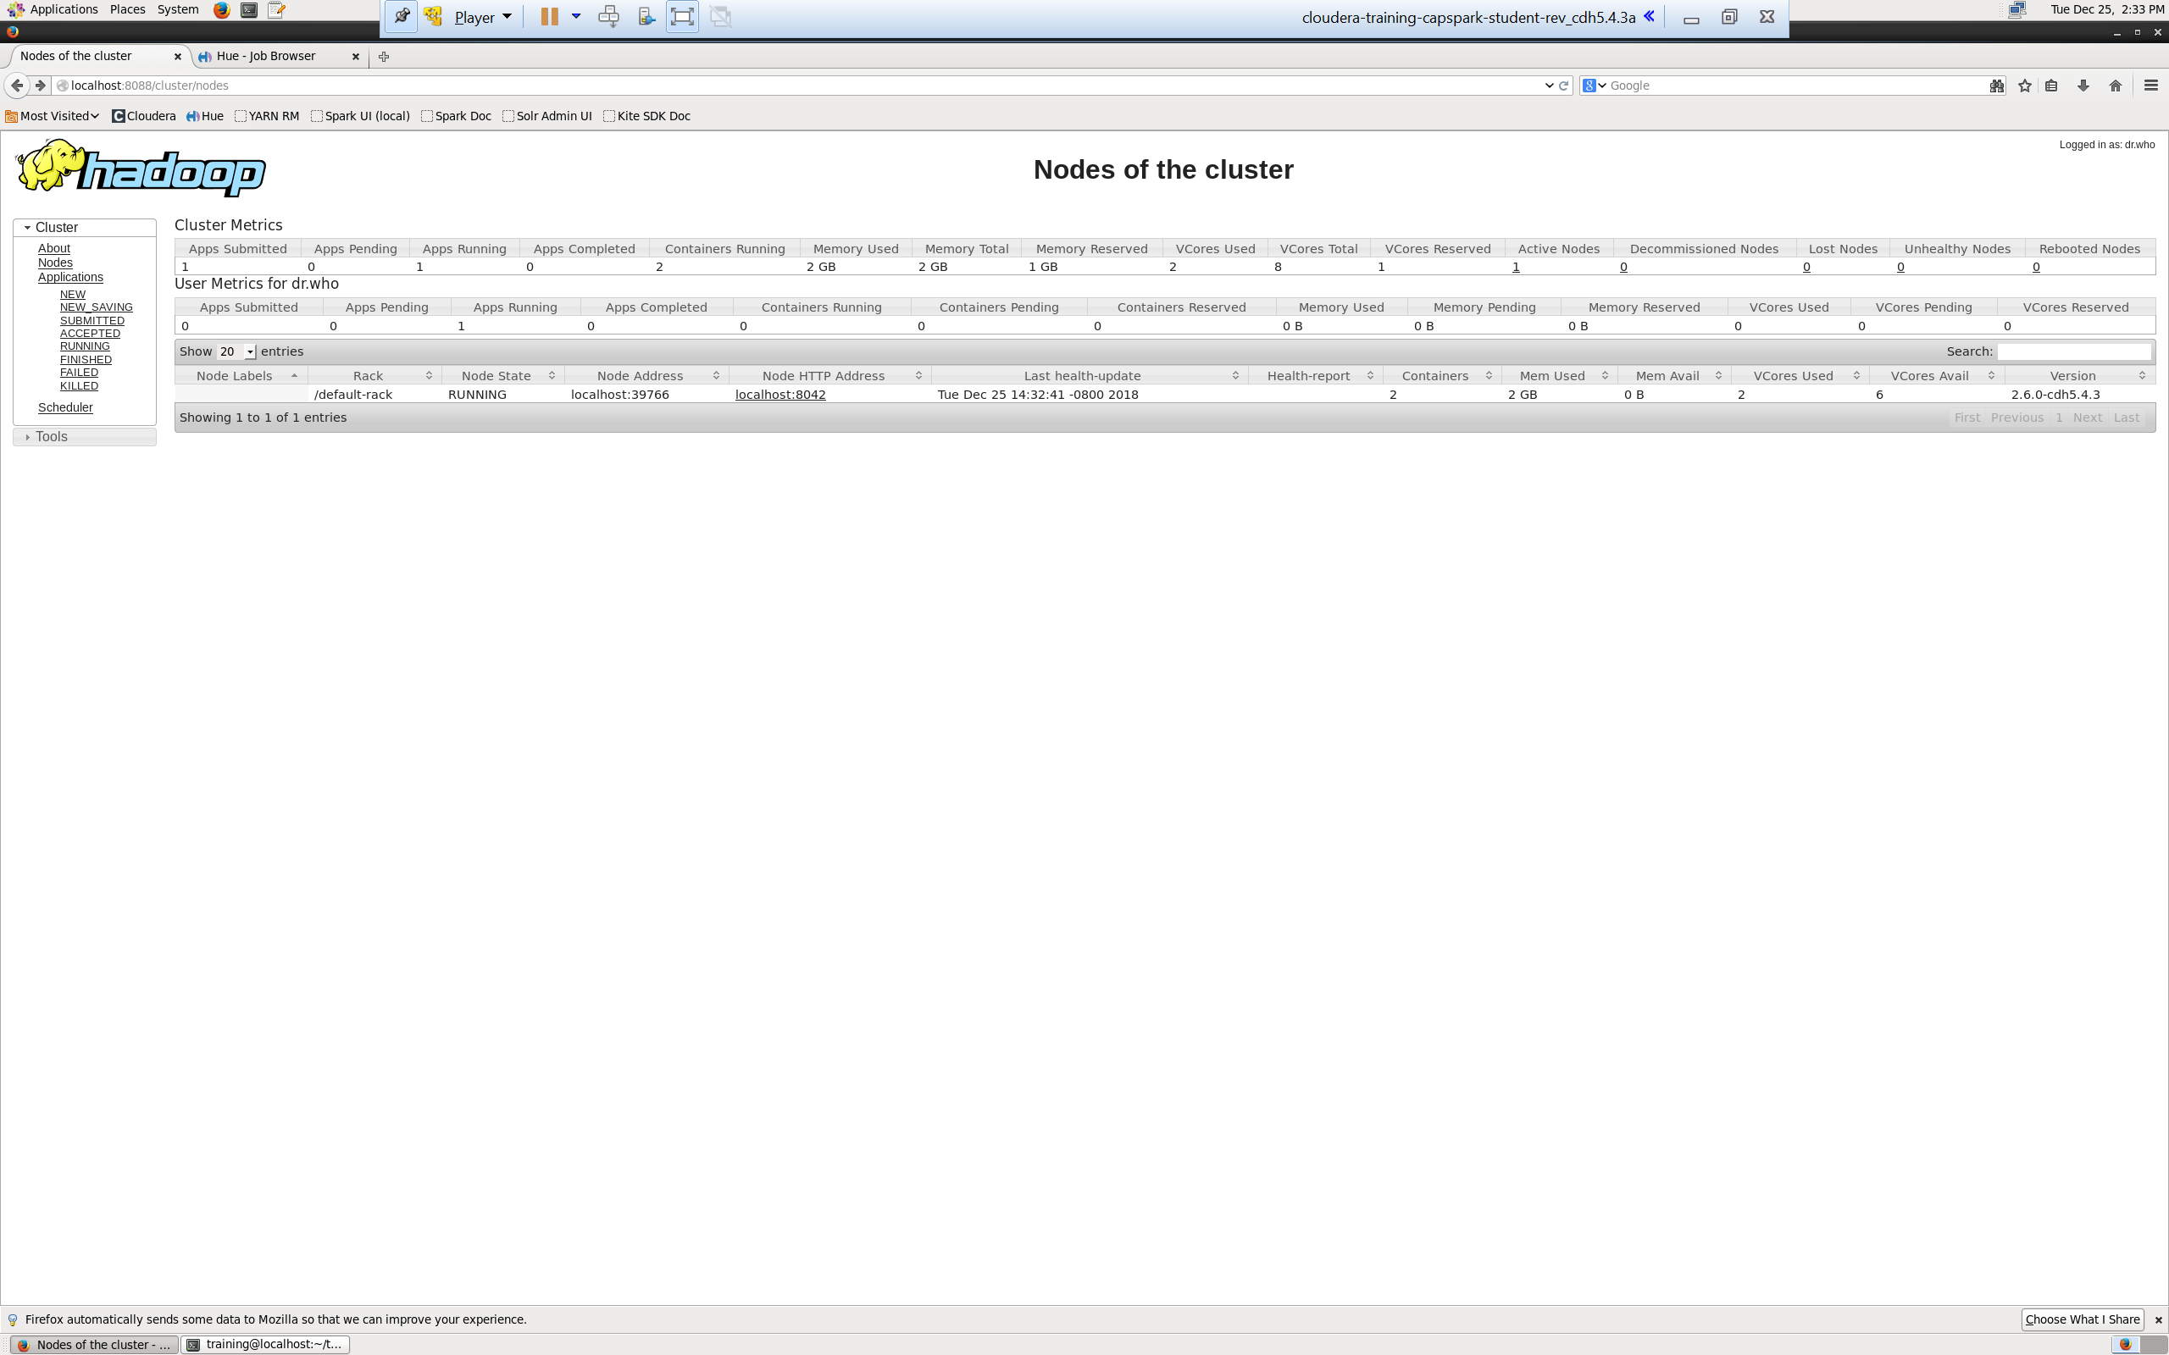Step-11: Click on the Nodes link, like we did in Step 4. Click on the “Node HTTP Address” link highlighted in the screenshot below.

Q. Take a screenshot of the YARN UI screen and paste it below.

Step-12: Click on the “Applications” link in the Node Manager menu options on the left side of the screen as shown in the screenshot below.

Q. Take a screenshot of the YARN UI screen and paste it below. Highlight the application that you started in Step 8.

Explanation: This screen displays the containers the Resource Manager allocated on the selected node for the current application. A container is created by the RM on request, it is assigned a certain amount of resources. An application is run on one or more containers.

NOTES:

1. If you don’t see any contains, that is because the application has finished running. Run the application again, you should see the containers.

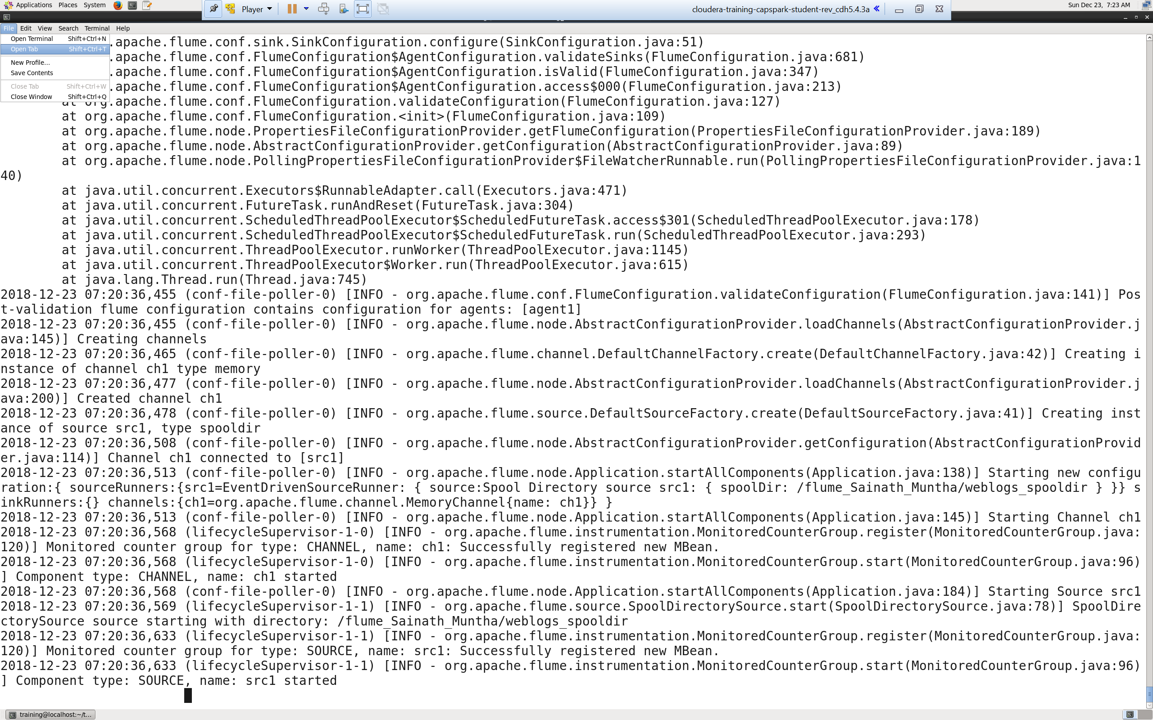Step-13: Open a separate terminal window by clicking on “File” then “Open tab” as shown in the screenshot below.

Step-14: Execute the following code at the shell prompt:



Q. Take a screenshot of the shell output and paste it below. Highlight the application ID.

Explanation: We can access YARN through the command line. The above command gives us a list of applications that are currently running.

NOTES:

1. If you don’t see any contains, that is because the application has finished running. Run the application again by re-executing Step-8.
2. Take note of your application ID in this step

Step-15: Execute the following code at the shell prompt:



Q. Take a screenshot of the shell output after executing the following command and paste it below.



Explanation: The above command kills the application that we specify with application_id.

NOTES:

1. If you don’t see any contains, that is because the application has finished running. Run the application again by re-executing Step-8
2. application_id is the id of the spark application that we started

Part-3: Finding Help: This section will cover how to get additional information about YARN.

Step-16: The following link also provides additional documentation about HDFS filesystem commands.

<https://hadoop.apache.org/docs/current/hadoop-yarn/hadoop-yarn-site/YarnCommands.html>

Q. Navigate to the webpage from the link provided above, take a screenshot of the landing page and paste it below.

Part-4: Checksum: In this section we will perform a checksum

Step-17: Download the Checksum.zip file from eLearning in to the downloads folder **IN** the Cloudera VM using Mozilla Firefox.

Step-18: Execute the following command:



Q. Now type the command and execute. Take a screenshot of the shell output, highlight the zip file and paste it below.

Step-19: Execute the following command at the shell prompt:



Q. Now type the command and execute. Take a screenshot of the shell output, highlight the contents of the zip file and paste it below.

Explanation: The “unzip” command unzips the zip file.

Step-20: Execute the following command at the shell prompt:

Then execute the following command:

Q. Take a screenshot of the shell output and paste it below.

Step-21: Execute the following command at the shell prompt:





Q. Now type the command and execute. Take a screenshot of the shell output and paste it below.

# ADDITIONAL NOTES:

* Make sure to check the spelling before you execute a command, a spelling mistake in one step can snowball and prevent other steps from working.
* Execute means, type in the given command and hit return/enter
* Shell output refers to the output that you see in the terminal application after executing a command
* **SUBMIT A WORD DOCUMENT CONTAINING YOUR SCREENSHOTS IN ELEARNING.**
* **Also submit the Checksum value (32-bit alpha numeric key) from Step-20 in the comments section of the submission as shown in the screenshot below:**

